**Python Data Types in Action: Building an Order Processing System**

In modern e-commerce platforms, order processing is a critical component. Whether you're running a small online store or a large retail business, being able to calculate costs, apply taxes, and determ.

[[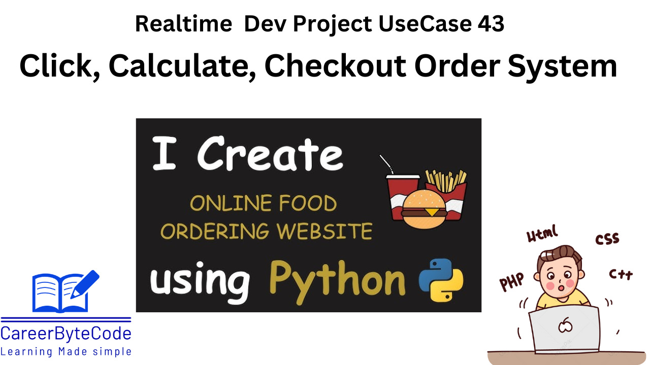](https://substackcdn.com/image/fetch/$s_!pCZ8!,f_auto,q_auto:good,fl_progressive:steep/https%3A%2F%2Fsubstack-post-media.s3.amazonaws.com%2Fpublic%2Fimages%2Fb74978b0-4b99-459f-9c80-7404bee763dd_1280x720.png)](https://substackcdn.com/image/fetch/$s_!pCZ8!,f_auto,q_auto:good,fl_progressive:steep/https%3A%2F%2Fsubstack-post-media.s3.amazonaws.com%2Fpublic%2Fimages%2Fb74978b0-4b99-459f-9c80-7404bee763dd_1280x720.png" \t "_blank)

**1. Scenario**

An online shopping platform needs a system to process orders. When a customer places an order, the system should:

* Store the customer's name (string).
* Store the number of items ordered (int).
* Store the total price, including tax (float).
* Check if the customer is eligible for free shipping (boolean).

The system should calculate the final amount after applying tax and determine if free shipping is applicable for orders above ₹1000.

**2. Problem Statement**

Develop a Python program that takes a customer's name, the number of items purchased, and the total amount before tax. The program should:

1. Calculate the total cost after adding **GST (18%)**.
2. Check if the order qualifies for free shipping (orders above ₹1000).
3. Display the order summary with all details.

**3. Why We Need This Use Case**

In modern e-commerce platforms, **order processing is a critical component**. Whether you're running a small online store or a large retail business, being able to calculate costs, apply taxes, and determine shipping eligibility in real-time is essential.  
This use case showcases how **basic Python data types (int, float, str, bool)** are applied in a real-world business scenario to:

* Collect and validate customer input
* Perform tax calculations
* Determine shipping eligibility
* Display a clean, user-friendly order summary

It also introduces beginner programmers to structured, modular, and functional thinking using Python.

**4. When We Need This Use Case**

This use case is useful when:

* You're building a **simple checkout/order processing module** for an e-commerce application.
* You want to teach or learn how **Python handles user input and performs calculations**.
* You need to create **testable scripts** for business simulations or educational tools.
* You’re developing a system that needs to **log customer details and transaction summaries**.

**5. Challenge Scenarios**

1. 🧾 Orders with values just below and above ₹1000 — testing free shipping logic.
2. 💻 Invalid user input like entering text instead of a number — requires handling.
3. 📦 Bulk orders with 100+ items — test performance and formatting.
4. 🔢 Orders with very high value (₹1,00,000+) — test float precision.
5. 🧮 Orders with zero or negative amount — should be flagged.
6. 🔄 Calculating with different tax rates (5%, 12%, etc.) — for adaptability.
7. 🚫 Missing inputs or empty strings — validation needed.
8. 👥 Handling multiple orders in one session — scope extension.
9. 🌐 Multi-currency support — convert amounts before processing.  
   🔟 📈 Generating reports or receipts — exporting to files or sending emails.
10. What happens if a user enters a negative number of items?  
    Scenario: A customer accidentally inputs -2 items. Your system processes the order without validation.
11. How will you handle input like "ten" instead of 10?  
    Scenario: A customer types "ten" when asked how many items they are purchasing.
12. Modify the program to handle different GST rates (5%, 12%, 18%).  
    Scenario: Some products have different tax slabs depending on their category.
13. What changes are needed to apply discounts for first-time users?  
    Scenario: First-time buyers get a 10% discount before tax is added.
14. Add support for multiple currencies (₹, $, €).  
    Scenario: Your shopping site has customers from India, USA, and Europe.
15. Store multiple customer orders in a list and display all summaries.  
    Scenario: You want to process orders from 5 customers in one session.
16. How would you export the order summary to a text file?  
    Scenario: A customer wants a downloadable receipt of their order.
17. Add an input for shipping address and include it in the summary.  
    Scenario: The company starts home delivery and needs the customer's address.
18. What happens if GST is accidentally entered as 0%?  
    Scenario: Due to a typo in code, tax is calculated as zero for all customers.
19. Limit free shipping only to metro cities. How would you modify the logic?  
    Scenario: Free shipping is allowed for orders above ₹1000 only in Chennai, Mumbai, Delhi, and Bangalore.
20. What if a customer’s name input is empty?  
    Scenario: A user just presses enter without typing anything when asked for their name.
21. Allow customers to purchase more than one product type. How would you handle this?  
    Scenario: A customer buys 2 mobile phones and 3 power banks — each with separate pricing.
22. Add product-wise pricing and calculate itemized cost.  
    Scenario: Each item has a different cost (e.g., Laptop = ₹60,000, Mouse = ₹1,200).
23. Apply shipping fees for orders below ₹500.  
    Scenario: ₹100 shipping fee is added if the total (after tax) is less than ₹500.
24. Add input validation: Prevent floats in item count.  
    Scenario: A user accidentally enters 2.5 as the number of items.
25. Display the date and time of the order in the summary.  
    Scenario: Orders should have a timestamp for record-keeping.
26. Use a function to encapsulate the entire order process.  
    Scenario: Your company wants the entire order logic inside a reusable function.
27. How would you store orders in a CSV file for later analysis?  
    Scenario: You want to analyze sales trends at the end of the week.
28. Create a loyalty system where frequent buyers get 5% off.  
    Scenario: Customers with more than 5 previous purchases get a discount.
29. Accept multiple orders in one session and calculate the grand total.  
    Scenario: A customer places multiple orders back-to-back in one checkout session.
30. Add error handling using try-except for numeric inputs.  
    Scenario: Users often enter invalid inputs causing the program to crash.
31. Make the program bilingual (English & Hindi).  
    Scenario: The shopping portal supports English and Hindi interfaces.
32. Add a delivery date based on location (e.g., 2 days for local, 5 days for remote).  
    Scenario: Different locations have different delivery times.
33. Add a feature to apply coupon codes like "WELCOME100" or "SAVE10".  
    Scenario: Customers use coupon codes for discounts.
34. How would you make this system web-based using Flask?  
    Scenario: Your company wants to turn the CLI program into a web-based order form.

**6. Prerequisites for the Lab**

To try out this lab successfully, users should know:

✔️ **Python Basics** — variables, input/output  
✔️ **Data Types** — int, float, str, bool  
✔️ **Arithmetic Operations** — addition, multiplication  
✔️ **Conditional Statements** — if, else  
✔️ **Formatted Output** — using f-strings

**7. Advantages and Disadvantages**

**✅ Advantages:**

* Teaches real-world application of data types
* Easy for beginners to follow and implement
* Fully interactive — takes user input
* Great starting point for larger systems like cart management or billing
* Can be extended to web or GUI apps later

**❌ Disadvantages:**

* Limited to single-order sessions
* No input validation for incorrect types
* Tax rate is hardcoded — not dynamic
* No persistent data storage (like file or database)
* Doesn’t support product-wise item pricing yet

**8. Step-by-Step Implementation**

**Python Program**

# Step 1: Input customer details

customer\_name = input("Enter Customer Name: ") # String

num\_items = int(input("Enter Number of Items Purchased: ")) # Integer

total\_before\_tax = float(input("Enter Total Amount Before Tax: ₹")) # Float

# Step 2: Calculate tax and final price

gst\_rate = 18 / 100 # 18% GST

tax\_amount = total\_before\_tax \* gst\_rate

total\_after\_tax = total\_before\_tax + tax\_amount

# Step 3: Determine free shipping eligibility

free\_shipping = total\_after\_tax > 1000 # Boolean

# Step 4: Display order summary

print("\n===== Order Summary =====")

print(f"Customer Name: {customer\_name}")

print(f"Items Purchased: {num\_items}")

print(f"Total Before Tax: ₹{total\_before\_tax:.2f}")

print(f"GST (18%): ₹{tax\_amount:.2f}")

print(f"Total After Tax: ₹{total\_after\_tax:.2f}")

print(f"Eligible for Free Shipping: {'Yes' if free\_shipping else 'No'}")

**Step 1: Accept User Input**

* Use input() to get the customer's name.
* Convert num\_items to an integer using int().
* Convert total\_before\_tax to a float using float().

**Step 2: Perform Calculations**

* **GST Calculation**: Multiply the total amount before tax by 18% to get the tax amount.
* **Final Price Calculation**: Add the tax amount to total\_before\_tax.

**Step 3: Determine Free Shipping**

* If the final amount (after tax) is **greater than ₹1000**, set free\_shipping = True, else False.

**Step 4: Display Order Summary**

* Print the order details, ensuring proper formatting using f-strings.
* Use a conditional expression ('Yes' if free\_shipping else 'No') for displaying free shipping eligibility.

**Sample Output**

**Test Case 2: Order Above ₹1000**

Enter Customer Name: John

Enter Number of Items Purchased: 3

Enter Total Amount Before Tax: ₹450

===== Order Summary =====

Customer Name: John

Items Purchased: 3

Total Before Tax: ₹450.00

GST (18%): ₹81.00

Total After Tax: ₹531.00

Eligible for Free Shipping: No

**Test Case 2: Order Above ₹1000**

Enter Customer Name: Peter

Enter Number of Items Purchased: 2

Enter Total Amount Before Tax: ₹1500

===== Order Summary =====

Customer Name: Peter

Items Purchased: 2

Total Before Tax: ₹1500.00

GST (18%): ₹270.00

Total After Tax: ₹1770.00

Eligible for Free Shipping: Yes

**9. Conclusion**

This use case **bridges theoretical Python knowledge with real-world application**. It demonstrates how a few lines of code using str, int, float, and bool can solve actual business challenges.

✅ **Learning Outcomes:**

* Apply basic data types in a meaningful context
* Write user-interactive scripts
* Understand conditional logic and formatted output
* Learn how to simulate an order-processing scenario

🔁 This project is a great base for adding product catalogs, discount systems, or integration with payment gateways!